Step 1: open MySQL and display the ‘customers’ table.

* mysql -u root –pbigdata
* show databases;
* use retail_db;
* show tables;
* desc customers;

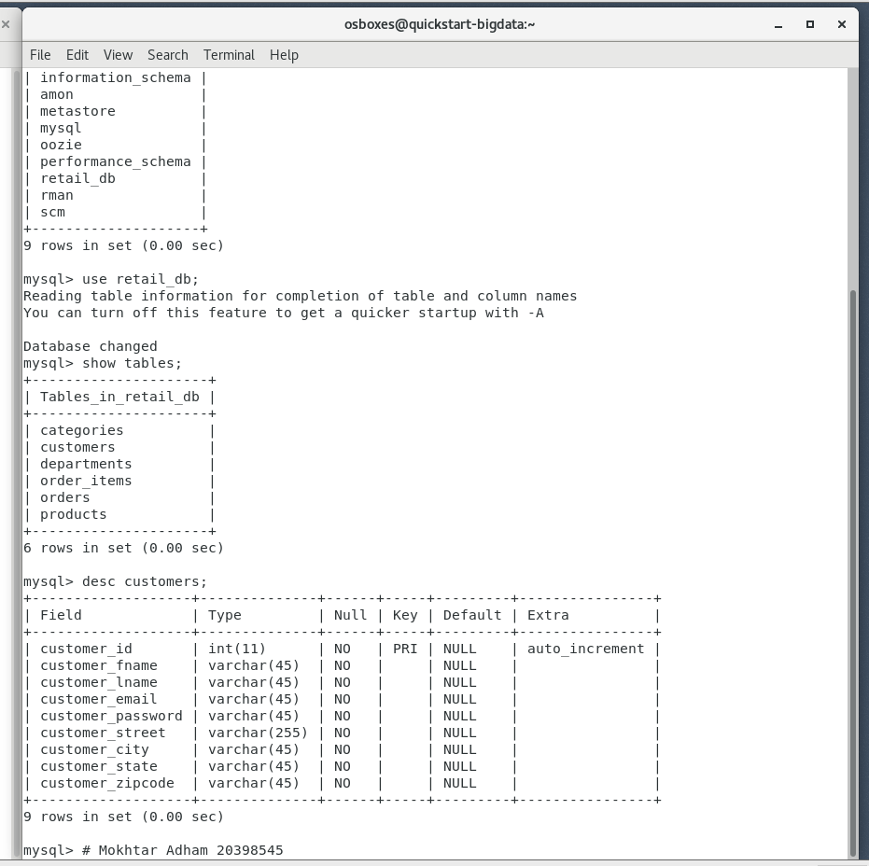

Step 2: create Hbase table

* create 'customers', 'CustomerInfo', 'ContactInfo', 'miscellaneous'
* list
* describe 'customers'

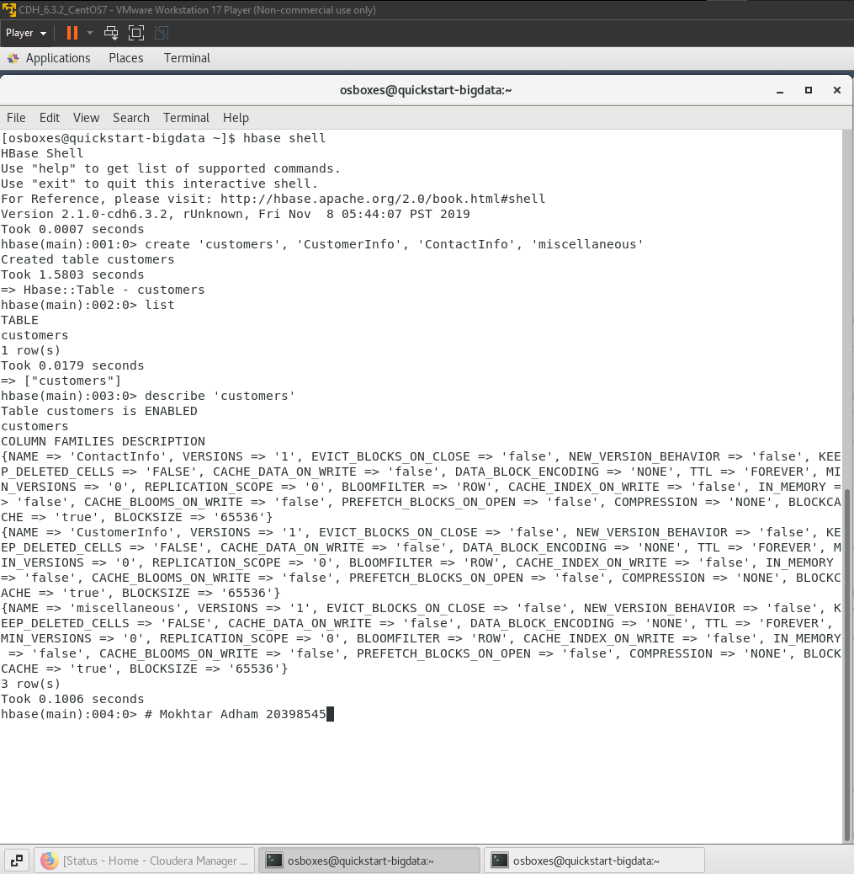

Step 3: import data from mysql to hbase table

Step 3.1: import data to CustomerInfo family column

* sqoop import --connect jdbc:mysql://192.168.45.135/retail_db --username root --password bigdata --table customers --columns "customer_id, customer_fname, customer_lname, customer_email, customer_password" --hbase-table customers --column-family CustomerInfo --hbase-row-key customer_id -m 1

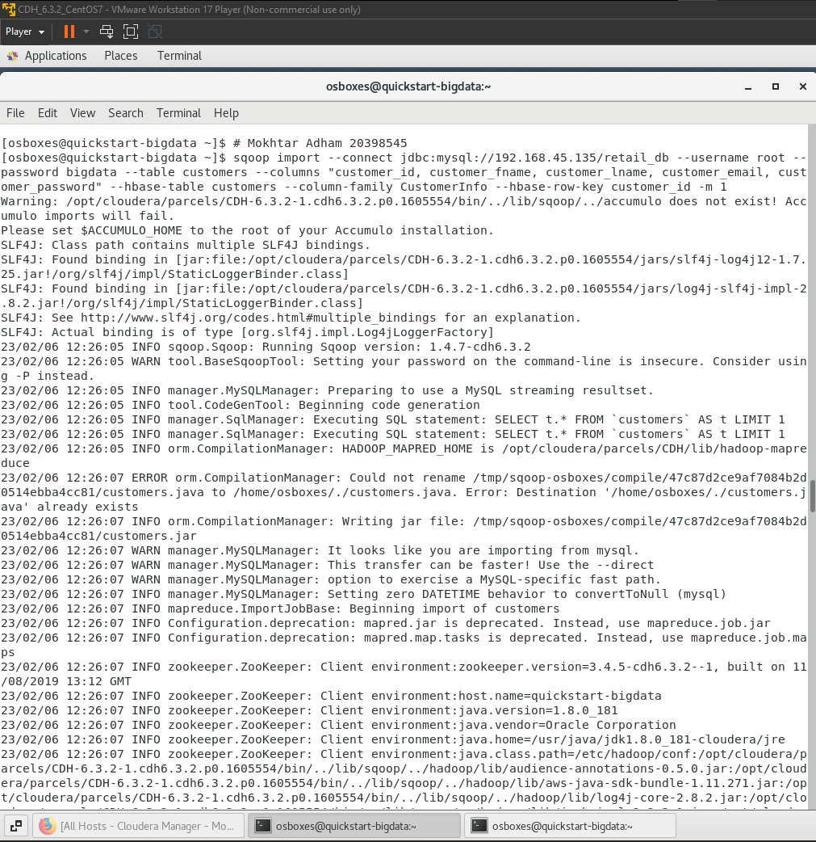

Step 3.1: import data to CustomerInfo family column

* The job completed successfully and retrieved 12435 records.

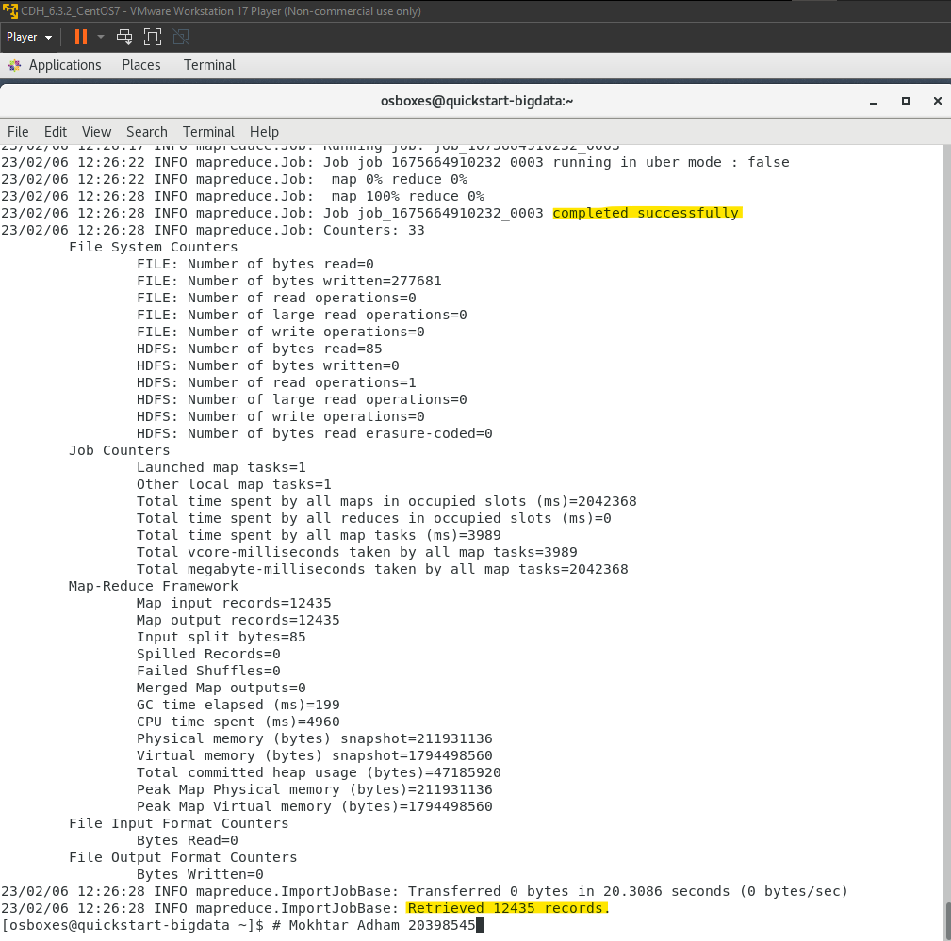

Step 3.2: import data to ContactInfo family column

* sqoop import --connect jdbc:mysql://192.168.45.135/retail_db --username root --password bigdata --table customers --columns "customer_id, customer_street, customer_city, customer_state, customer_zipcode" --hbase-table customers --column-family ContactInfo --hbase-row-key customer_id -m 1

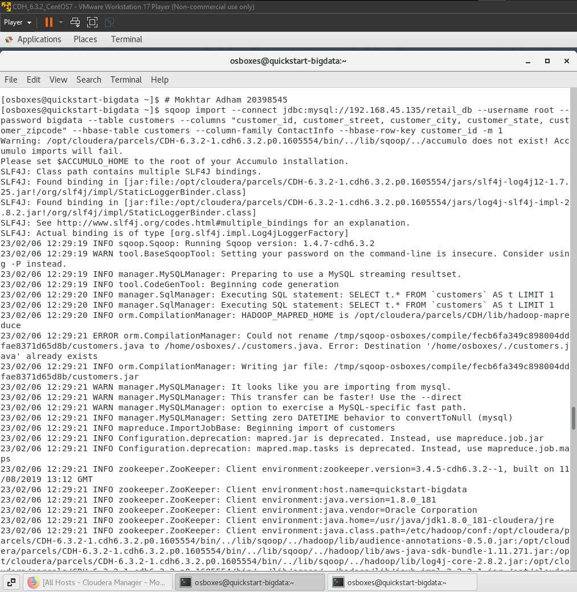

Step 3.2: import data to ContactInfo family column

* The job completed successfully and retrieved 12435 records.

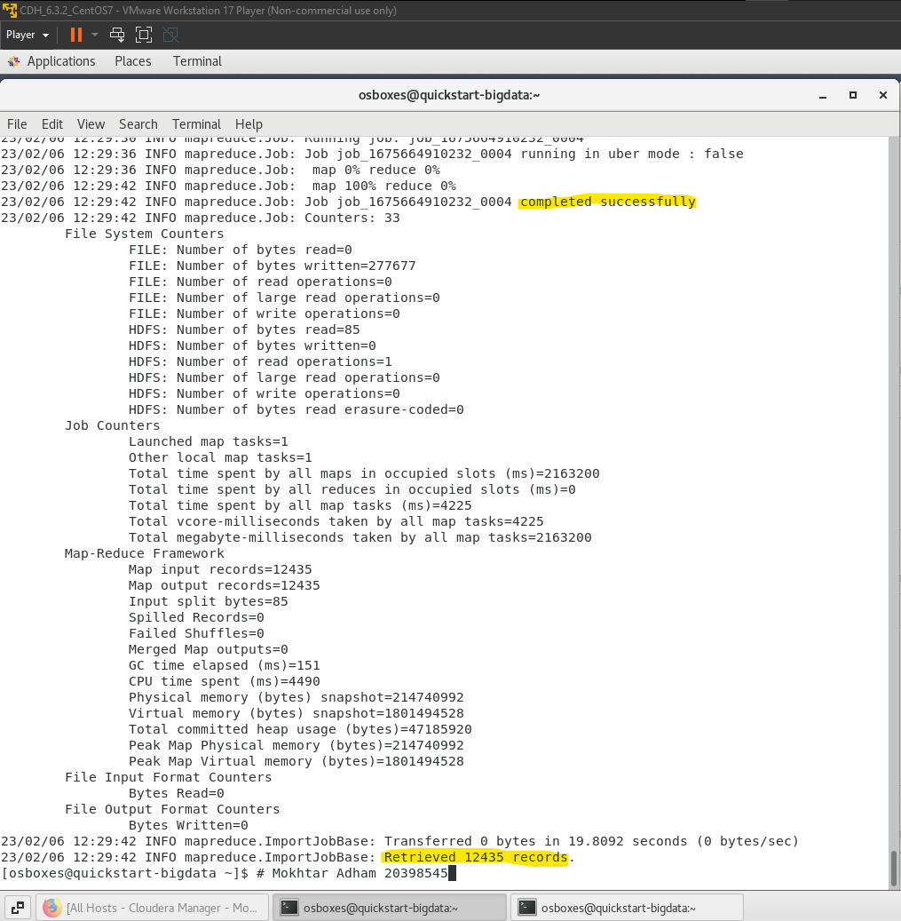

Step 4: import libraries to filter the data

* import org.apache.hadoop.hbase.filter.CompareFilter
* import org.apache.hadoop.hbase.filter.SingleColumnValueFilter
* import org.apache.hadoop.hbase.filter.SubstringComparator
* import org.apache.hadoop.hbase.util.Bytes

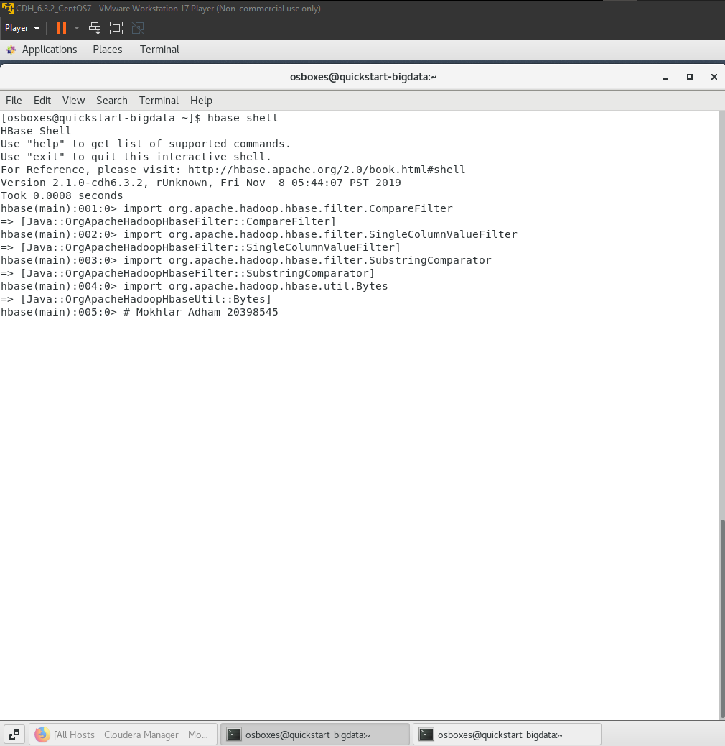

Step 4.1: filter the data to retrieve the first 20 rows of ContactInfo family column where customer_state equal ‘NY’.

* scan 'customers', { COLUMNS => 'ContactInfo:customer_state', LIMIT => 20, FILTER => "ValueFilter( =, 'binaryprefix:NY' )" }

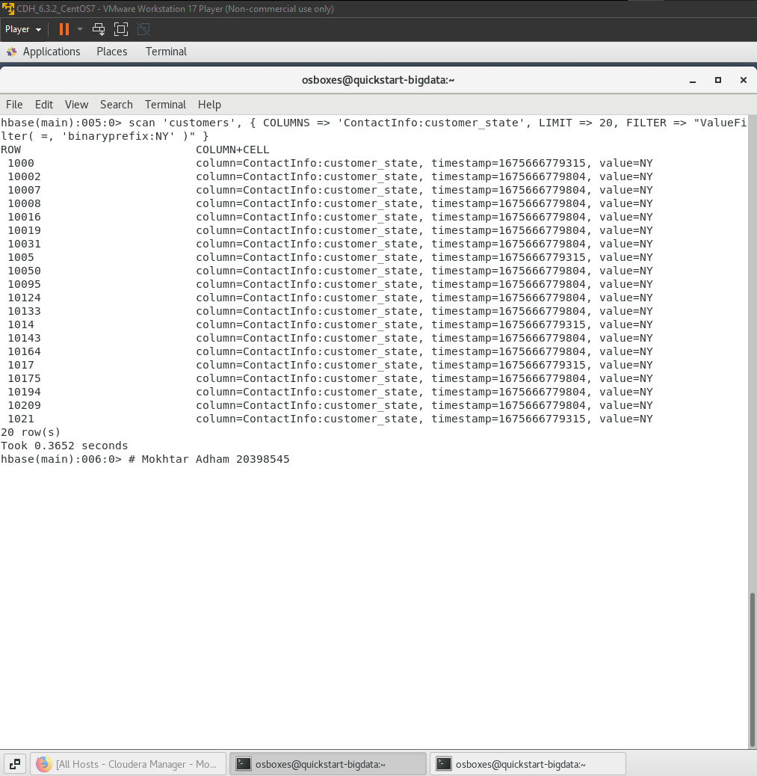

Step 4.1: filter the data to retrieve the first 20 rows of ContactInfo family column where customer_state equal ‘VA’.

* scan 'customers', { COLUMNS => 'ContactInfo:customer_state', LIMIT => 20, FILTER => "ValueFilter( =, 'binaryprefix:VA' )" }

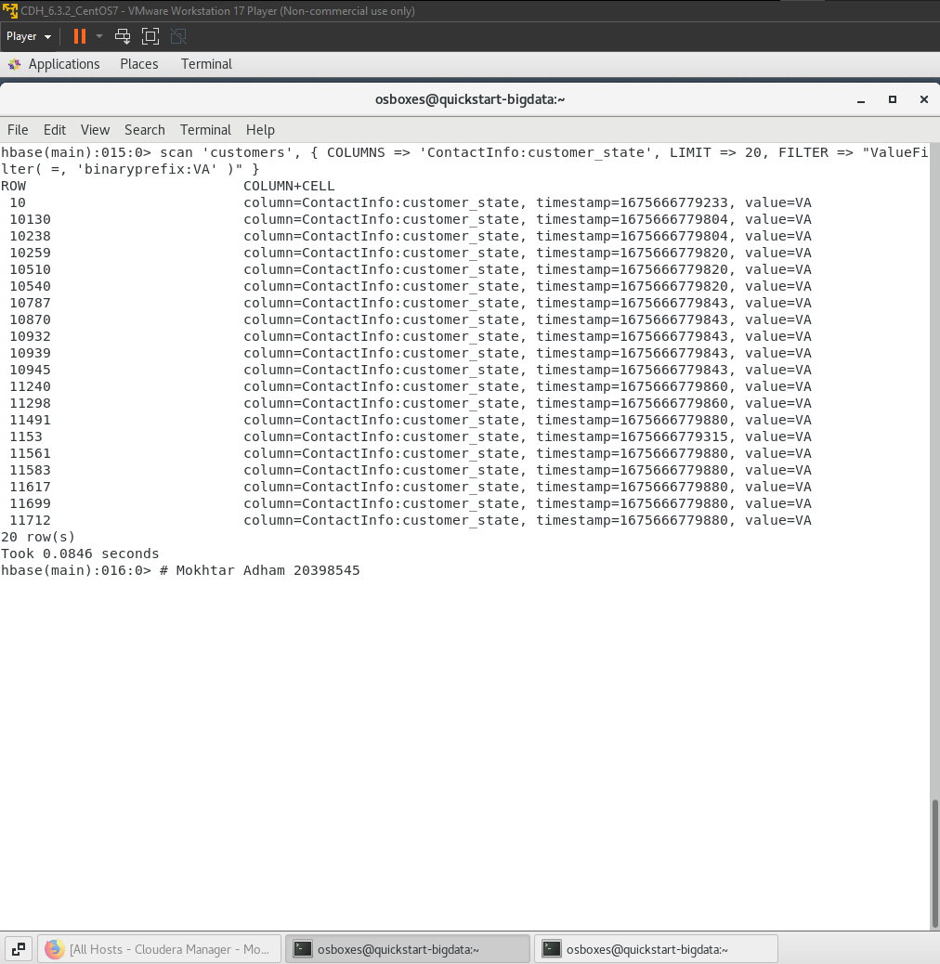

Step 5.1: display all possible commands in HBase

* click (ctrl + tab) then click (y)

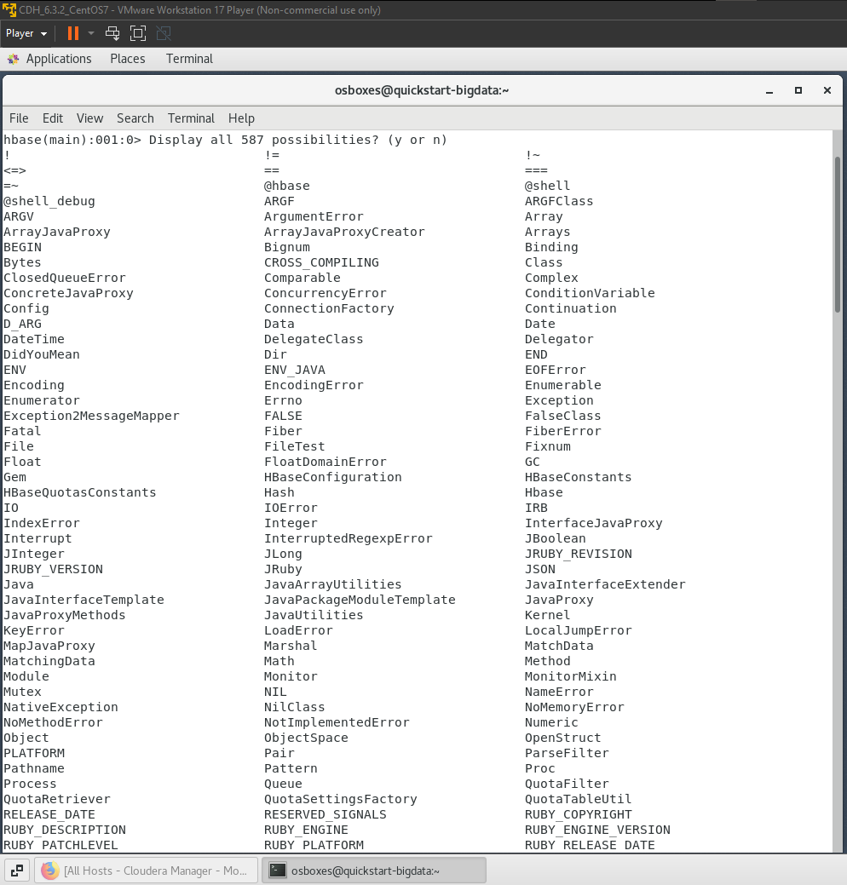

Step 5.1: display all possible commands in HBase (cont.)

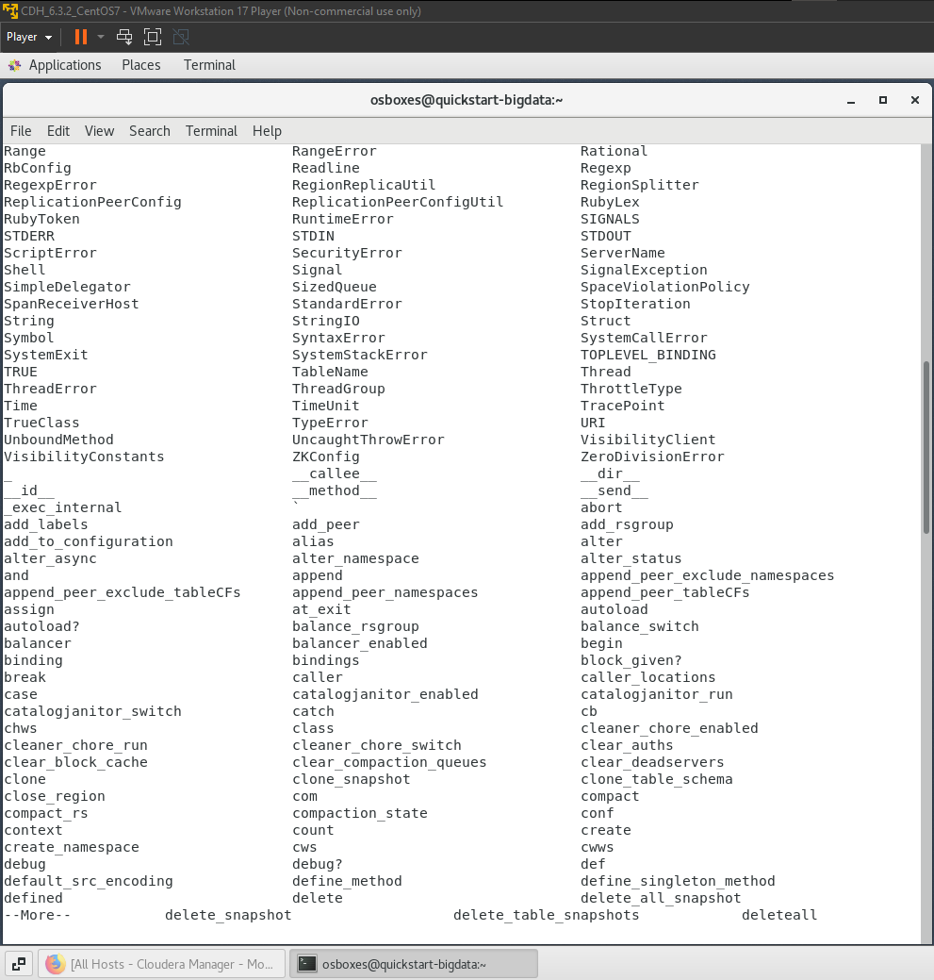

Step 5.1: display all possible commands in HBase (cont.)

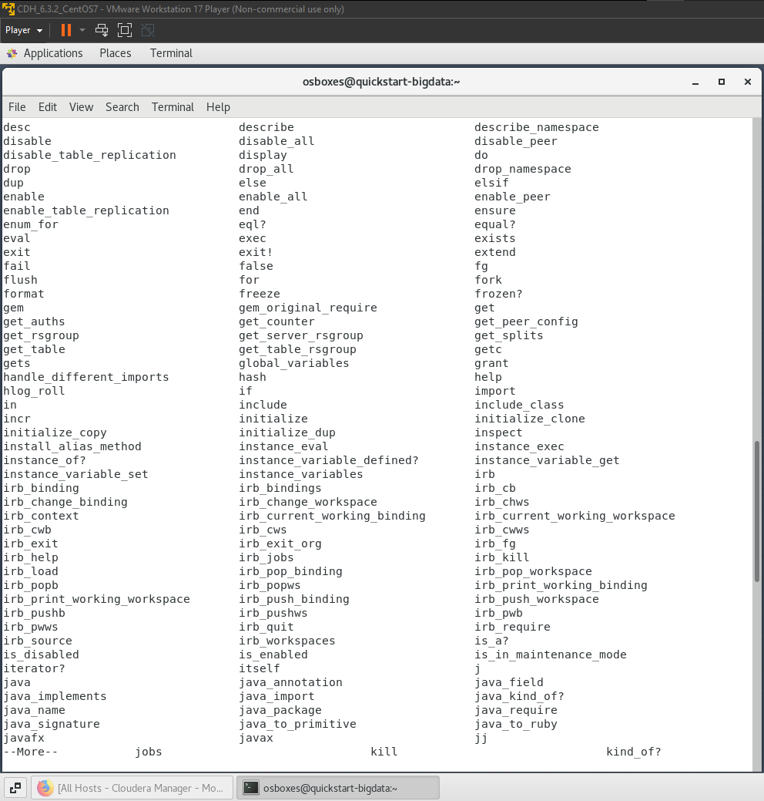

Step 5.1: display all possible commands in HBase (cont.)

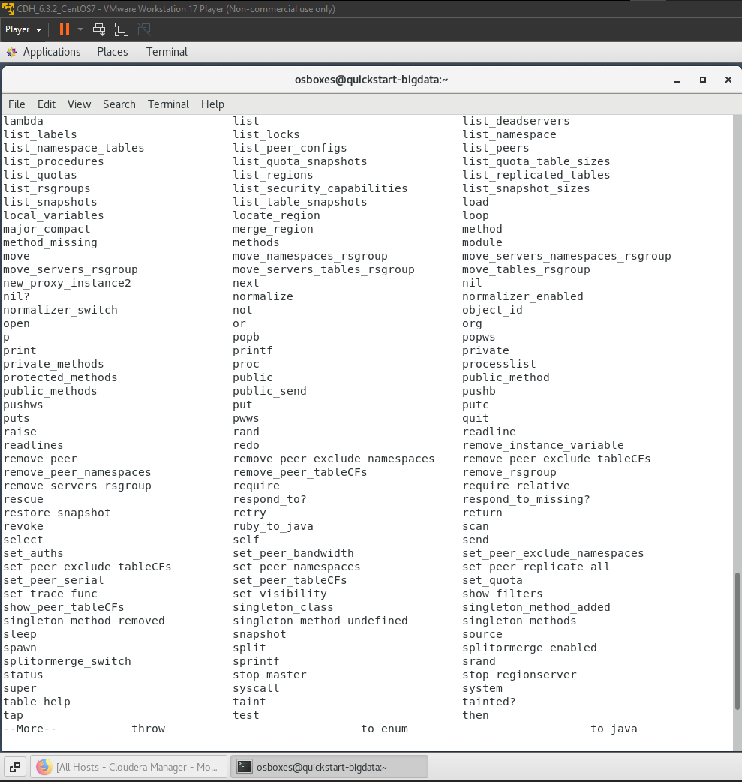

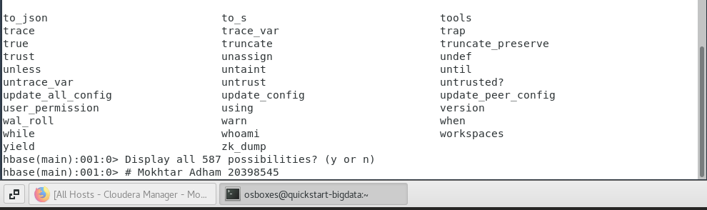

Step 5.2: display all possible commands in HBase (cont.)

* count ‘customers’
  + for displaying rows count.
* scan ‘customers’
  + for displaying the rows details but we added a limit to minimize the output.
* disable ‘customers’
  + for stop any actions on the table and stop using it.
* Drop ‘customers’
  + To drop the table.

